🏭 Our Products Section
1. Compostable Carry Bags
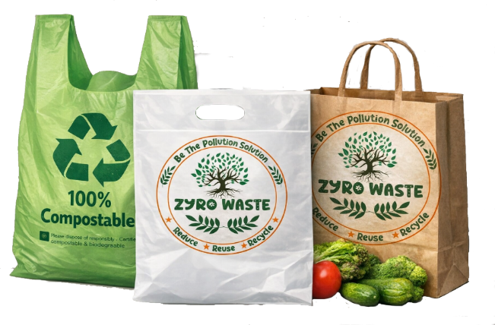
Best For:
Retail stores, supermarkets, clothing shops, pharmacies
Features:
- Material: Corn Starch, PLA, PBAT
- Thickness: Starts from 15 microns
- Capacity: 1–20 KG
- Types: U-Cut, W-Cut, D-Cut
- Custom printing available

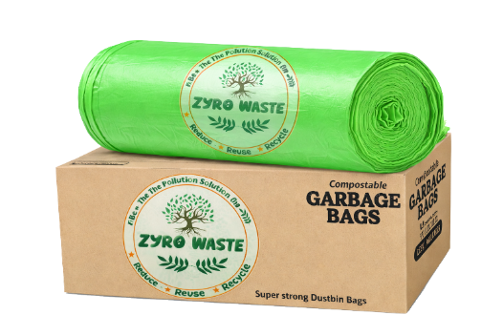
2. Compostable Garbage Bags
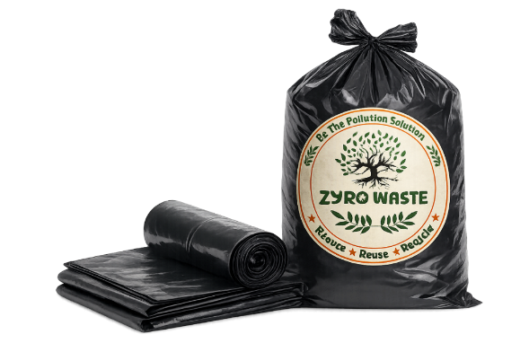
Best For:
Hotels, apartments, hospitals, municipalities
Features:
- Capacity: 5L to 240L
- Flat seal & star seal options
- With or without core
- Strong & leak-proof

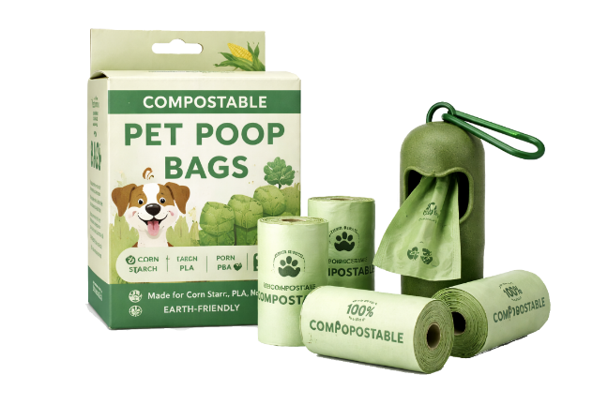

3. Compostable Pet Poop Bags
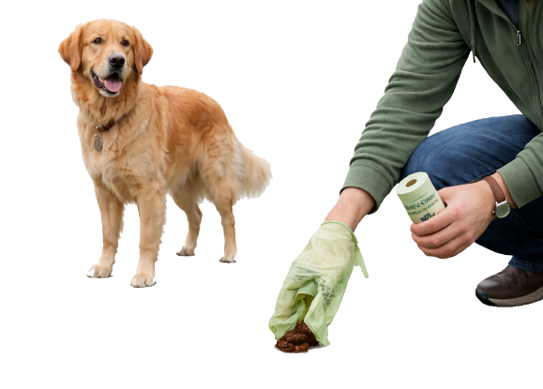
Best For:
Pet owners, residential & municipal use
Features:
- Capacity: 3L to 5L
- Easy tear perforation
- Compact and eco-friendly

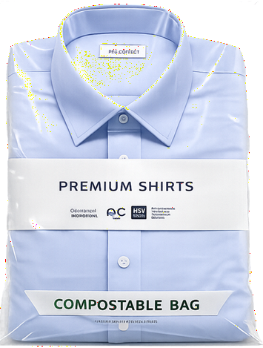
4. Compostable Apparel Bags
Best For:
E-commerce brands, clothing stores
Features:
- Self-adhesive seal
- Starting thickness: 25 microns
- Custom colors & branding

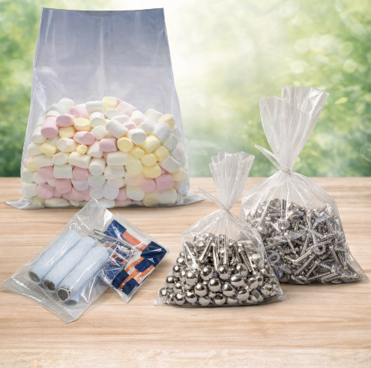
5. Custom Compostable Bags
Best For:
Healthcare, restaurants, electronics, events
Features:
- Fully customizable
- Side seal / wrap options
- Branding with eco-friendly inks

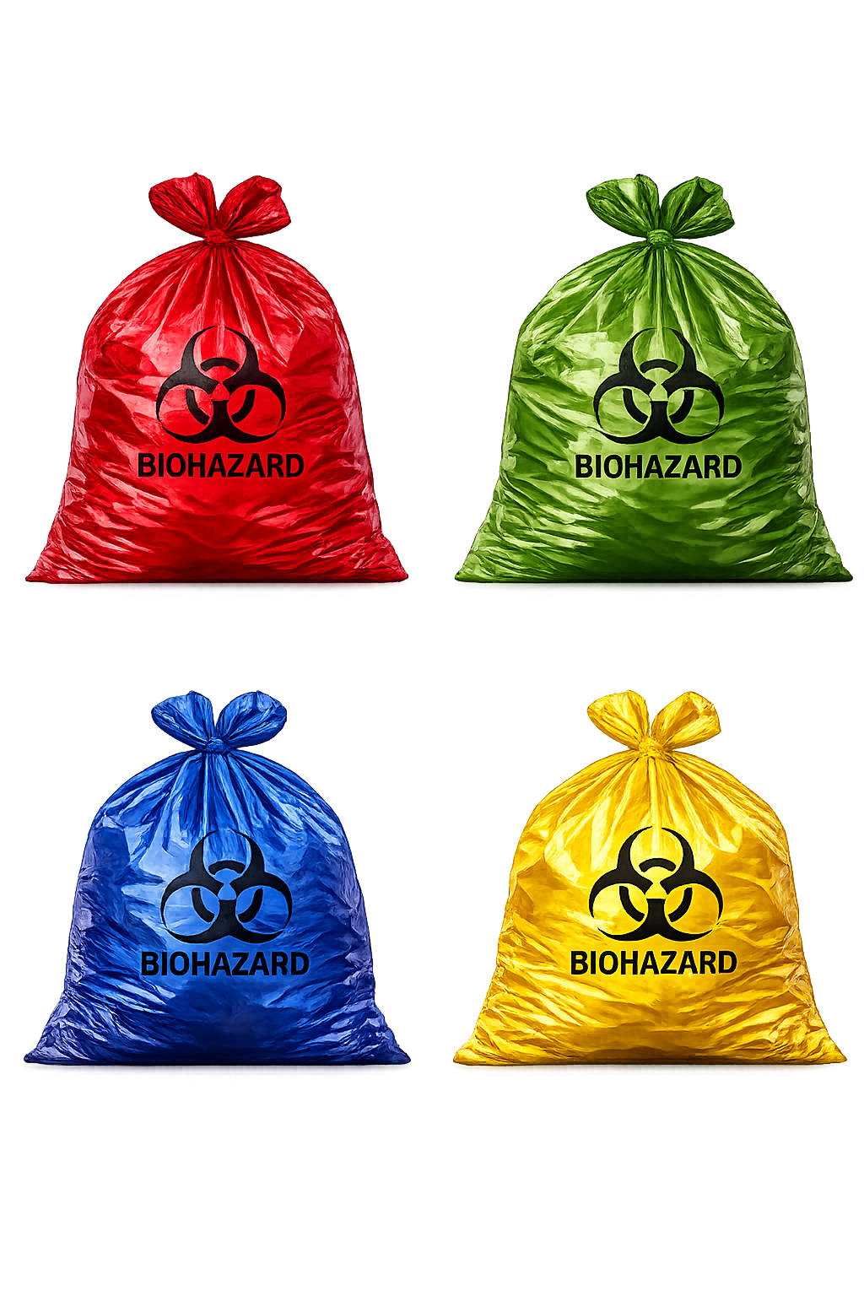
Red Biohazard Bags
Used for disposal of contaminated recyclable plastic waste.
Used For:
- IV tubes & sets
- Catheters & urine bags
- Syringes (without needles)
- Gloves
Disposal Method:
Autoclaving / Disinfection followed by recycling
Key Feature:
Safe handling of infectious plastic waste



Yellow Biohazard Bags
Used for highly infectious and non-recyclable medical waste.
Used For:
- Human tissues & body parts
- Blood-soaked bandages
- Cotton, dressings
- Expired medicines
Disposal Method:
Incineration (high-temperature burning)
⚠️ Important:
Most critical category – requires strict handling



Blue Biohazard Bags / Containers
Used for glass and metallic biomedical waste.
Used For:
- Glass bottles & vials
- Broken glass
- Metallic implants
Disposal Method:
Disinfection and recycling


Green Waste Bags (General Waste)
Used for non-medical and non-infectious waste.
Used For:
- Food waste
- Paper & packaging
- General garbage
Disposal Method:
Municipal waste disposal
Note:
Not classified as biomedical waste

